

Sweetwater County
Resource List

Developed By
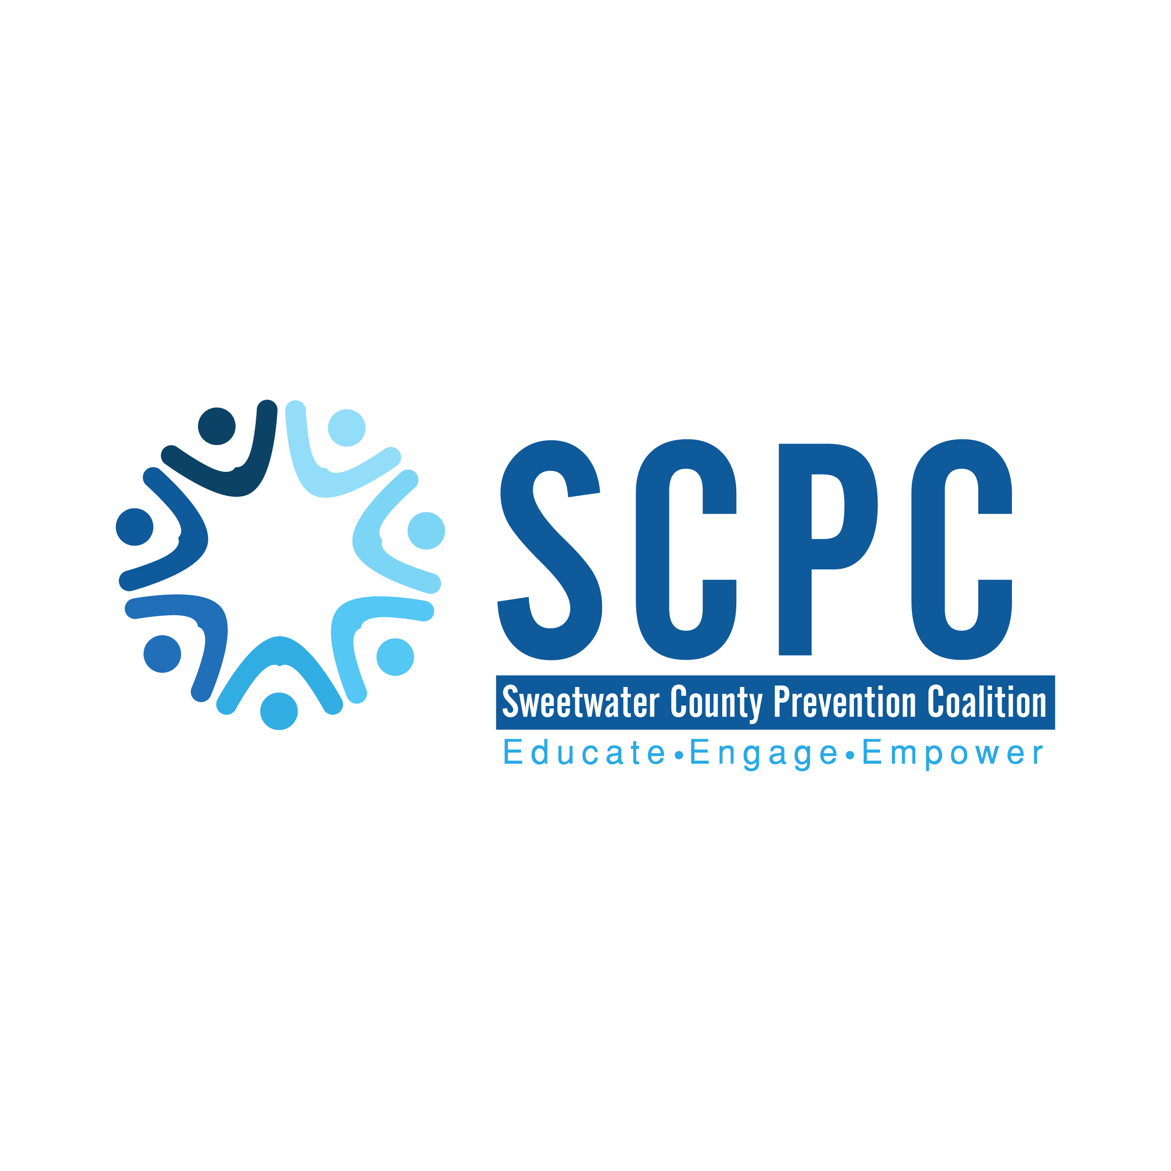

We would like to thank the members of the Sweetwater County Prevention Coalition for their diligent effort for helping us put this resource list together.

Updated August 8, 2025

Table of Contents
Table of Contents 3
Counseling and Mental Health 4
Victim Services 8
Support Groups 10
Food Assistance 12
Housing and Low Income Assistance 14
Childcare, Early Childhood Education 17
Education and Employment 20
Parenting 22
Instacare/Clinics 23
Sweetwater County Prevention Coalition 24

*Organizations with an asterisk are also youth serving organizations.

Counseling and Mental Health

National Lines:
Suicide Prevention Lifeline
Support for people who are in a suicidal crisis or emotional distress. Provides prevention and crisis resources.
988
Available 24/7 – Confidential – Free
1-800-273-8255 (TALK)
Spanish Speaking
1-888-628-9454
Disponible 24/7 – Confidencial – Gratis
Deaf or Hard of Hearing
711 then 1-800-799-4889
Veterans
1-800-273-8255 and Press 1
Text Line
(307) 776-0610
ImAlive Crisis Chatline
Live online instant messaging network for people in crisis available 24/7.
Go to: imalive.org
Crisis Text Line
Crisis intervention texting hotline available 24/7.
Text HOME to 741-741
The Trevor Project
Hotline, webchat, and text service available 24/7 for LGBTQ youth.
TrevorLifeline
1-866-488-7386
TrevorChat
thetrevorproject.org/get-help-now
TrevorText
Text “START” to 678-678
Local Resources:
Southwest Counseling Service*
Counseling for individuals, children, adolescents, and families. Groups for mental health, substance abuse, and psychosocial. Clinical assessments, outpatient, and inpatient services. Psychiatric, and medical services. Sober Living and Supported Independent Living Program. Youth summer program. Telehealth option.
Sliding fee scale, accepts Medicaid
Website: www.swcounseling.org
Local 24 Hour Crisis Line:
307-352-6677
Mental Health Services
1124 College Dr.
Rock Springs, WY 82901
Phone: (307) 352-6680
Hours:
Mon. & Wed. 8:00am – 8:00pm
Tue. & Thur. 8:00am – 6:00pm
Fri. 8:00 am – 1:00 pm
Recovery & Billing Services
2300 Foothill Blvd.
Rock Springs, WY 82901
Phone: (307) 352-6677
Hours:
Mon. & Wed. 8:00am – 9:00pm
Tue. & Thur. 8:00am – 7:00pm
Fri. 8:00am – 7:30pm
Medical & Psychosocial Services
2706 Ankeny Way
Rock Springs, WY 82901
Phone: (307) 352-6689
Hours:
Mon. - Thur. 8:00am – 5:00pm
Fri. 8:00am – 12:00pm

Rock Springs Community Health Center (Bear Lake Community Health)
Medical, Dental, Pharmacy, OB/GYN, Behavioral Health,
Telehealth option.
Sliding fee scale, payment plans, accepts Medicaid.
2620 Commercial Way, Suite #140
Rock Springs, WY 82901
Phone: Clinic- (307) 212-5116 Pharmacy- (307) 212-5105
Office Hours
Monday-Friday: 8:00am – 6:00pm
After-Hours Clinical Advice Services Available 24/7
Pharmacy Hours
Monday – Friday 8:00am – 6:30pm
Lunch from 1:30pm – 2:00pm
Website:
www.bearlakecommunityhealthcenter.org

Better Solutions Counseling
Individual, family, couples, art therapy and EMDR therapy. Psychological & psycho-educational services. Specializes in autism, physical, mental, or cognitive disabilities, crisis counseling, and general counseling.
Accepts Medicaid. Bills insurance.
2001 Dewar Drive
Suites 230 and 270
Rock Springs, WY 82901
Phone: (307) 382-3058
Website: www.bettersolutionscounseling.com

High Point Counseling*
Individuals, couples, family, youth and adult counseling. Psychological testing. Addiction, trauma, and marriage counseling. Telehealth option.
Accepts Medicaid
2632 Foothill Blvd. Suite 101
Rock Springs, WY 82901
Phone: (307) 212-8014
Hours: Mon. – Thur. 9:00am – 5:00pm
Website: www.highpointcounseling.com
Sweetwater Counseling*
Family and Trauma therapy. Cognitive behavioral therapy. EMDR therapy.
Youth and adults.
1471 Dewar Drive Suite 214,
Rock Springs, WY 82901
Phone: (307) 389-4674
Email: rtschroeder@me.com
Website:
www.sweetwatercounseling.com

Wellness Associates*
Individuals, couples, families. Mental health, eating disorders. Sport psychology, seminars. Nutrition, fitness, and weight management.
Takes Medicaid
1471 Dewar Dr
Rock Springs, WY 82901
Phone: (307) 630-3466
Hours: Appointments available Monday thru Saturday
Website: www.wacounseling.com
WEvolve Counseling*
Therapy for self-harm, trauma and PTSD. Individuals and couples. Adults and adolescent. Telehealth offered.
1471 Dewar Drive #209
Rock Springs, WY 82901
Phone: (307) 352-9161
Hours: Mon. – Fri. 8:30am – 5:30pm
Website:
www.wevolve-counseling.com
Access Balance & Change*
Treatment for adults, treatment for adolescents, evaluations. Individuals, couples, and family therapy.
Accepts Medicaid
126 Elk St.
Rock Springs, WY 82901
Phone: (307) 382-6330
Hours:
Mon. – Thur. 9:00am – 6:00pm
Website: www.abcrocksprings.com

Wellbeing & Accessibility*
Free counseling services for students at Western. Crisis services for students. Help with accommodations for students who need them. Relaxation room.
2500 College Dr., Room 1227
Rock Springs WY, 82901
Phone: (307)382-1652
Hours: Mon. – Fri. 8:00am – 5:00pm
Website:
www.westernwyoming.edu >
Student Life Tab >
Campus Amenities >
Wellbeing & Accessibility
Professional Counseling Services, LLC*
Individual and family therapy. Therapy for trauma and PTSD. EMDR and Synergy Play Therapy certified. Children, adolescents, and adults. LGBTQIA2+
Accepts Medicare

50 Shoshone Ave STE B,
Green River, WY 82935
Phone: 307-337-9830
Hours: Tues--Thurs. 9:00am--5:00pm
Fri: 9:00am-1:00pm

Website: www.mindytollefson.com

Mind Works Behavioral Health, LLC*
Individuals, families, children, adolescents, and adult therapy. Person-centered and trauma focused. Accepts Medicaid

538 Pilot Butte Ave Suite 5,
Rock Springs, WY 82901
Phone: 307-228-5950
Hours: Mon – Thurs.

Website: www.mindworksbehavioralhealth.clientsecure.me

Roots to Rise*
Play therapy and counseling services. ART therapy. Children, adolescents, and adults.

408 S Main Street
Rock Springs, WY 82901
Phone: 307-374-4014

Website: www.roottoriseinc.com

Victim Services
NATIONAL LINES
National Domestic Violence Hotline – The Hotline
Support for victims and survivors of domestic violence. Provides information, education, and referral services.
Hotline
1-800-799-SAFE (7233)
Available 24/7 – Confidential – Free
Live Chat/Website
thehotline.org
Text Line
Text “START” to 1-800-799-7233
RAINN National Sexual Violence Hotline
Support for victims and survivors of sexual assault. Provides information, advice, or referral services.
Hotline
1-800-656-HOPE (4673)
Available 24/7 – Confidential – Free
Live Chat/Website
www.rainn.org
App
Visit website for more information.
Love is Respect – National Teen Dating Abuse Hotline
Provides support, information, and advocacy to young people who have questions about their relationships. Available 24/7 – Confidential - Free
Hotline
1-866-331-947
Text
Text “LOVEIS” to 22522
Live Chat/Website
www.loveisrespect.org
Local Resources
YWCA Center for Families and Children
Helps with safety planning, protection order/court accompaniment, emergency shelter and basic needs, economic assistance, and referrals to law enforcement, job programs and housing services.
Local 24 Hour Crisis Line:
307-352-1030 or 307-872-3250
Rock Springs:
2620 Commercial Way #5
Rock Springs, WY 82901
Phone: (307) 382-3124
Email: cfc@ywcasweetwater.org
Hours: Mon. – Thur. 8:30am-5:00pm
Green River:
6 N. 1st E
Green River, WY 82935
Phone: (307) 872-3250
Website:
www.ywcasweetwater.org
Memorial Hospital of Sweetwater County – SANE Program
Team trained to help sexual assault victims, performing medical, psychological, and forensic exams.
1200 College Drive
Rock Springs, WY 82901
Contact: Tiffany Uranker-Webb
Phone: (307) 372-3711
Email: turanker@sweetwatermemorial.com
Website:
www.sweetwatermemorial.com

County Attorney’s Office – Victim/Witness Program
Provide support and community referrals. Assist victims with filing for compensation. Provide information about case and court procedures. Accompany witnesses and victims to court. Act as your liaison with the criminal justice system.
Rock Springs:
50140C US HWY 191 South STE 400
Rock Springs, WY 82901
Contact: Sadie Trapp
Phone: (307) 922-5264
Email: trapps@sweet.wy.us
Contact: Matt Beardsley
Phone: (307) 922-5265
Email: beardsleym@sweet.wy.us
Green River:
80 West Flaming Gorge Way, STE 21
Green River, WY 82901
Contact: Sandy Lake
Phone: (307) 872-3829
Email: lakes@sweet.wy.us

Support Groups

National & Local
Alcoholics Anonymous
Support for people experiencing alcoholism.
District 8 Hotline:
(307) 362-8421
Rock Springs Group
402 S. Main St.
Rock Springs, WY 82901
Meetings:
Mon. – Sat. @ Noon
Mon. Wed. Fri. @ 6:30pm
Mon. – Sun. @ 8:00pm
First Things First Group
WWCC
2500 College Drive
Rock Springs, WY 82901
Meetings:
Mon. Wed. Fri. @ 5:30
Tomahawk Group
86 N. 1st E. St
Green River, WY 82901
Meetings:
Mon., Wed – Sun. @ Noon
Mon. – Sun. @ 8:30pm
Local Website:
www.area76aawyoming.org
*The website has a list of active online meetings.
International Website:
www.aa.org
App:
Meeting Guide
*Free meeting finder that provides meeting information for AA services.
LDS 12 Step
Support for addictions.
Phone:
(307) 679-5221
Meeting:
Sun. @ 5:00 pm
*Meeting is currently only offered on zoom. Contact phone number for more information or go to website.
Website:
www.addictionrecovery.churchofjesuschrist.org
Narcotics Anonymous
Support for people experiencing addiction to drugs.
Hotline: (307) 371-5836
Surrender to Win Group
Union Congregational Church
350 Mansface St.
Green River, WY 82935
Meetings:
Sun. & Thurs. @ 8:00pm
Welcome Home Group
New Hope Church
513 G St
Rock Springs, WY 82901
Meetings:
Wed. @ Noon
Sun. Tue. Fri. @ 8:00pm
Serenity Group
100 Clearwater Dr.
Rock Springs, WY 82901
Meetings:
Mon. Thur. Sat. @ 7:00pm
Website:
www.urmrna.org
Al-Anon Family Groups
Support for people who have a loved one experiencing alcoholism
Rock Springs Brown Bag AFG
402 S. Main
Rock Springs, WY 82901
Meetings:
Tue. @ Noon
Green River Tomahawk AFG
96 N. 1st E. St, Room 205
Green River, WY 82935
Meetings:
Wednesday @ 7:00pm
Website:
www.al-anon.org
Suicide Bereavement Support Group
Support for people whose lives have been affected by suicide.
400 C St.
Rock Springs, WY 82901
Contact: Jim Horan
Phone: (207) 504-6581
Meeting: Every first Monday of the month.
Gamblers Anonymous
Support for people who are experiencing gambling addiction. Online meetings available.
Hotline:
1-855-2 CALL-GA (855-222-5542)
Website:
www.gamblersanonymous.org

Grief Support Group
A grief support group available to the public.
Rock Springs Worship Center
3317 Dewar Dr.
Rock Springs, WY 82901
Meetings: First Sunday of the month @ 1:00pm

Food Assistance

Local Assistance
Bishops Storehouse
Food assistance.
210 Shoshone Ave.
Green River, WY 82935
Phone: (307)875-3972
Hours: Mon. – Sat. by appointment only. Closed Sun. and Holidays.
Cent$ible Nutrition
Free cooking classes, cookbook, and other items to help with healthy eating. Contact to see when classes are being held.
Housed in WWCC
2500 College Drive
Rock Springs, WY 82901
Phone: (307)352-6775
or (307)872-6310
Website:
www.uwyocnp.org
The Cupboard of Sweetwater County
This is a Facebook group where members of the community can go give items away or ask for items they might need to help get them through. “Online version of borrowing a cup of sugar from a neighbor.” Also has informative posts about traveling food pantries and other helpful information for Sweetwater County. Must be a member of the group to post or see what others posted
Hand Up Food Cart
A food cart for community members who need a little extra help. Stocked by community members for community members.
1049 Truman St.
Rock Springs, WY 82901
Hours: Daily 8:00am – 7:30pm
Loaves and Fishes
A soup kitchen and emergency food pantry. Located in the basement of Saints Cyril & Methodius Catholic church.
633 Bridger Ave.
Rock Springs, WY 82901
Phone: (307)362-2611
Hours: Mon.– Fri. 12:00pm – 1:00pm
Facebook:
@loavesandfishessoup
Sweetwater Food Bank
Free bimonthly distribution of food to low income families. (Also houses the diaper bank.)
Rock Springs
90 Center St.
Rock Springs, WY 82901
Phone: (307)382-7332
Distribution:
2nd & 4th Thur.
10:00am-2:45pm & 4:00pm-5:45pm
Green River
550 Uinta Dr. Ste F
Green River, WY 82901
Phone: (307)875-9600
Distribution:
1st & 3rd Thur. 10:00am – 4:45pm
Website: www.foodbankswcty.org

SNAP at Department of Family Services
A program to help low-income families to buy food. Based on income and family size. Must fill out an application.
Housed in the White Mountain Mall
2451 Foothill Blvd. #103
Rock Springs, WY 82901
Phone: (307)362-5630
Hours: Mon.-Fri. 8:00am – 5:00pm
Website:
www.dfs.wyo.gov
Women Infants & Children Program (WIC)
Supplemental food and nutritional information for perinatal women and children up to 5 years old. Also help with breastfeeding support.
2620 Commercial Way #40
Rock Springs, WY 82901
Phone: (307)352-6783
Hours: Mon.-Fri. 8:00am-5:00pm
Website:
www.health.wyo.gov >Divisions >Public Health Division >Women, Infants & Children

Young at Heart Senior Center
Provide home delivered meals to eligible seniors. Must be primarily homebound and unable to prepare meals.
Contact: Daphne Palmer
Phone: (307)352-6737 ext. 203
Deliveries:
Mon.-Fri. between 11:00am-1:00p
Website:
www.youngatheartcenter.org >Services Tab >Home Delivered Meals
Student Storehouse at Western Wyoming Community College
A food pantry for Western students who are food insecure. Students can contact college for more information
2500 College Dr. Rm. 1562
Rock Springs, WY 82901
Phone: (307)382-1600

Housing and Low Income Assistance
Local Resources
Bicentennial Apartments
Low income apartment complex. Has some apartments for elderly and disabled as well.
3723 Madison Dr.
Rock Springs, WY 82901
Phone: (307)382-5596
Carrington Pointe
Middle-income apartment complex. Accept Section 8 vouchers.
2475 Cascade Dr.
Rock Springs, WY 82901
Phone: (307)382-7755
Green Rock Village
Low-income apartments for over 62 or disabled persons regardless of age.
700 Crossbow Dr.
Green River, WY 82935
Phone: (307)875-1616
Office Hours:
Mon. – Fri. 9:00am-5:00pm
Email:
grvillageapartments@outlook.com
Rock Butte Apartments
Low-income apartment complex.
1400 Bridger Dr.
Green River, WY 82935
Phone: (307)875-7760
Website: www.rockbutte.com

Rock Springs Housing Authority
Low-income housing. No cost for application, once accepted applicant would be placed on a waiting list. Coat bank available.
233 C St.
Rock Springs, WY 82901
Phone: (307)352-1471
Website: www.rswy.net
Low Income Energy Assistance Program (LIEAP)
Pays part of winter heating bills for eligible people from November through May. Applications available online or at the Department of Family Services (Housed in the White Mountain Mall).
Phone:
1(800)246-4221
How to apply:
Submit an application online
www.lieapwyo.org
Fax application to:
(307)778-39433
Email application to:
lieapinfo@thealignteam.org
Mail application to:
P.O. Box 827
Cheyenne, WY 82003

YWCA Center for Families and Children
Help with rental assistance for families as well as emergency shelter and basic needs.
Local 24 Hour Crisis Line:
307-352-1030 or 307-872-3250
Rock Springs:
2620 Commercial Way #5
Rock Springs, WY 82901
Phone: (307) 382-3124
Email: cfc@ywcasweetwater.org
Hours: Mon. – Thur. 8:30am-5:00pm
Green River:
6 N. 1st E
Green River, WY 82935
Phone: (307) 872-3250
Website:
www.ywcasweetwater.org
Sweetwater Family Resource Center
Their family independence program helps people who are homeless or on the verge of homelessness with rent, utilities, and other needs.
649 N. Front St. Ste. A
Rock Springs, WY 82901
Phone: (307)362-6549
Hours: Tue. – Fri. 10:00am – 4:00pm
Email: sweetwaterfamily@gmail.com
Website: www.sfrcwyo.com

Star Bus
Transportation for low-income individuals. Fixed route service with a door-to-door service. If needed, can call one day in advance to schedule a pick up time.
Phone: (307)382-7827
or (307)875-7827
Community Diaper Bank of Sweetwater County
Families can receive one free package of diapers per child. They are distributed on regular distribution days at the food Bank.
Rock Springs
90 Center St.
Rock Springs, WY 82901
Phone: (307)382-7332
Distribution:
2nd & 4th Thur.
10:00am-2:45pm & 4:00pm-5:45pm
Green River
550 Uinta Dr. Ste F
Green River, WY 82901
Phone: (307)875-9600
Distribution:
1st & 3rd Thur. 10:00am – 4:45pm
Website:
www.swunitedway.org/diaperbanks

Thrift Stores

Rock Springs
Broadway Bargains
429 Broadway
Rock Springs, WY 82901
Phone: 307-362-8128
Hours: Mon-Fri: 10am-12pm, 1-4pm. Sat. 12:30-4pm
Goodwill Wyoming-Rock Springs
1254 Dewar Dr
Rock Springs, WY 82901
Phone: 307-382-8000
Hours: Mon - Sat: 9am - 7pm
Sun: 10am-6pm

Eileen’s Attic/Episcopal Thrift Store
507 5th St
Rock Springs, WY 82901
Phone: 307-362-3834
Hours: Tues-Sat: 10am-3pm

The Stellar Cellar
403 N Front St
Rock Springs, WY 82901
Phone: 307-389-7654
Hours: Tues-Fri: 11am-6pm, Sat: 11am-4pm

Green River

St. John’s Thrift Shop
68 E 2nd S St
Green River, WY 82935
Phone: 307-875-5955
Hours: Tues-Wed, Sat: 10am-2pm

Childcare, Early Childhood Education
Rock Springs*
Boys and Girls Club
Offer an after school program for children that offers many different learning opportunities and activities.
736 Massachusetts Ave.
Rock Springs, WY 82901
Phone: (307)382-2639
Email: bgcofsw@gmail.com
After School Program Hours:
Mon. – Fri. 2:50pm – 6:00pm
Website: www.bgcsweetwater.com
Child Development Centers of Sweetwater County
Offer developmental screenings, early childhood education, family intervention, and IEPs for children up to 5 years old. Have play therapy available for children on IEP and students at CDC.
Rock Springs
4509 Foothill Blvd.
Rock Springs, WY 82901
Phone: (307)352-6871
Hours: Mon.-Fri. 8:00am-4:00pm
Green River
1715 Hitching Post Dr.
Green River, WY 82901
Phone: (307)871-3290
Hours: Mon. – Fri. 8:00am – 4:00pm
Website: www.cdckids.org

Children’s Center at WWCC
Affordable childcare and early childhood education for students and employees at Western. Must be on campus when child is there. Children 2-5 years old.
Housed in Western
2500 College Dr.
Rock Springs, WY 82901
Contact: Susie Rawlings
Phone: (307)382-1669
Hours: Fall & Spring Semester
Mon. – Fri. 7:45am – 5:15pm
Summer Semester
Mon. – Thur. 7:00am-6:00pm
Website:
www.westernwyoming.edu >
Student Life Tab >
Campus Amenities >
Children’s Center
YWCA Early Care and Learning Centers
Daycare and early childhood education for infants up to 12 years old. Accepts assistance from DFS.
1035 Jackson St.
Rock Springs, WY 82901
Phone: (307)352-6635
Hours: Mon. – Fri. 5:45am – 6:30pm
Website: www.ywcasweetwater.org

Early Learning Center at Young at Heart
Childcare for children from infant to 5 years old. Provide breakfast, lunch, and snack daily.
2400 Reagan Ave.
Rock Springs WY, 82901
Contact: Brianna Romero
Phone: (307)382-0662
Email: brianna.romero@yahsc.org
Hours: Mon. – Fri. 6:30am – 6:00pm
Website: www.youngatheartcenter.org >Services Tab >Early Learning Center
Little Sage Daycare & Preschool
A daycare provider and preschool.
2400 Cache Valley Dr.
Rock Springs, WY 82901
Phone: (307)371-8573
Hours: Mon. – Fri. 6:30am – 5:30pm
Email: jenniferwharton82901@yahoo.com
Website: www.little-sage-daycare-preschool.business.site
Trinity Lutheran Little Lambs Preschool
Preschool for ages 3, 4, and 5.
3101 College Dr.
Rock Springs, WY 82901
Phone: (307)362-9655
Email: littlelambstlc@hotmail.com
Website: www.trinityrocksprings.com

Head Start
An early childhood education program for children ages 3-5 years old. Priority is given to families whose children have disabilities or who are low income. One classroom in Green River. Call for more information.
625 Ahsay Ave.
Rock Springs, WY 82901
Phone: (307)-352-3430
Website: www.hstart.sweetwater1.org
Imagine Preschool & Daycare
An early childhood education program to help children with kindergarten readiness.
725 C. St.
Rock Springs, WY 82901
Phone: (307)389-6646
Hours: Mon. – Fri. 7:30am – 5:30pm
Email: imaginepreschool71@gmail.com
Website: www.imaginepreschooldaycare.com
Mia’s Learning Tree
Preschool classes for ages 3-5 years old.
1275 Adams Ave.
Rock Springs, WY 84901
Phone: (307)350-2829
Email: thelearningtree1275@gmail.com

Green River*
Green River After School Program (GRASP)
An after school program for children Jr. Kindergarten through 5th grade. Open for full and half days as well with some exceptions. Starts the first day of school
Monroe Elementary
250 Monroe Ave.
Green River, WY 82935
Contact: Katie
Phone: (307)872-0514
Website: www.cityofgreenriver.org
>Government >City Departments > Parks & Recreation > Youth Programs & Activities >GRASP

Green River Co-Op Preschool
A preschool for children ages 3-6 years old. 2 day, 3 day, and 5 day programs depending on age. Classes available morning and afternoon.
840 Hitching Post Dr.
Green River, WY 82935
Phone: (307)875-9410
Email: gr.coop.wy@gmail.com
Website: grco-oppreschool.com

Kid & Co
Daycare and preschool.
595 Bramwell St.
Green River, WY 82935
Phone: (307)875-7511
Hours: Mon. – Fri. 6:30am – 5:30
Facebook: @kid-company-preschool-and-daycare
Welcome to the Jungle
A daycare provider, state licensed.
2315 Hitching Post Dr.
Green River, WY 82901
Phone: (307)871-3778
Hours: Mon. – Fri. 6:30am – 5:45 pm
Website:
www.junglechildren.business.site
Happy Heroes
Childcare center serving ages 1+.
520 Wilkes Dr. Ste. 2
Green River, WY 82901
Phone: (307)871-8928
Hours: Mon. – Fri. 7:00am – 5:30pm
Email: kimhappyheroes@gmail.com
Facebook: @happyheroeschildcare
Community Connections
Out of school time activities for Junior High and High School Kids.
Contact: Lisa Plant
Phone: (307)352-3475 ext. 4041

Education and Employment

Department of Workforce Services*
Help with finding jobs. Build a resume. Services to help further education or help a person gain employment. Unemployment services. Also, ask about the WIOA program.
2451 Foothill Blvd., #100
Rock Springs, WY
Phone: (307)382-2747
Hours:
Mon. – Fri. 8:00am – 12:00pm,
1:00pm – 5:00pm
Website: www.wyomingworkforce.org
Vocational Rehabilitation Division
Services to help a person with work or school. Help with referral, vocational and other training services, self-employment opportunities. Must have a physical or mental impairment to qualify.
2451 Foothill Blvd., #100
Rock Springs, WY 82901
Phone: (307)362-2770
Hours: Mon. – Fri. 8:00am – 5:00pm
Website: www.wyomingworkforce.org

Western Wyoming Community College*
Many different resources housed inside to help students to succeed and find resources.
2500 College Dr.
Rock Springs, WY 82901
Phone: (307)382-1600
Wellbeing and Accessibility
Help with IEP and 504 accommodations. ADA help and information. Free counseling.
Room: 1227
Phone: (307)382-1652
Hours: Mon. – Fri. 8:00am – 5:00pm
Website:
www.westernwyoming.edu >
Student Life Tab >
Campus Amenities >
Wellbeing & Accessibility
Peer Tutor Center
Tutoring for college and high school students in most subjects. Test proctoring for people who need accommodations.
Room: 2006
Phone: (307)382-1707
Hours: Vary depending on the day, call for more information.
Website: www.westernwyoming.edu>
Student Life Tab>
Campus Amenities >
Peer Tutor Center

The Learning Center
Help with college and career readiness, high school equivalency, credit recovery, educational brush up, and English as a Second Language help.
Room: 2051
Phone: (307)382-1829
Website: www.westernwyoming.edu>
Academics Tab>
Support Services>
College & Career Readiness
UW Outreach Center/Educational Opportunity Center
Free help to assist with FAFSA completion, admissions applications and fees, understanding financial aid awards, scholarship applications, and travel reimbursements.
Contact: Amber Taylor
Room: 2011
Phone: (307)220-2232
Hours: By appointment
Email: ataylo45@uwyo.edu
Climb Wyoming
Provide a variety of free job training programs for low-income single mothers.
4020 Dewar Dr., Ste. B
Rock Springs, WY 82901
Phone: (307)382-0771
Email: sweetwater@climbwyoming.org
Hours: Mon. – Fri. 9:00am – 5:00pm
Website: www.climbwyoming.org

Thrive Independent Living (Goodwill)*
This program is focused on youth and alumni who are or were in foster care become self-sufficient adults. Help with education, employment, life skills training, housing, transition plans, and college assistance.
Contact: April Dittman
Phone: (307)371-9909
Email: april.dittman@goodwillwy.org
Hours: Mon. – Fri. 7:00am – 6:00pm (But hours can vary according to youth’s schedule.)
Magellan’s Wraparound Services*
Helps connect youth with services. They bring all the parties to the table. Work with many kids, CPS cases, and help reunify families. Program is paid for by Medicaid but there are waivers for families who do not have Medicaid. Serve ages 4-21.
Phone: (307)459-6162
Website: www.magellanofwyoming.com
Financial Empowerment Classes at YWCA
Individual or group classes to work on issues such as budgeting, paying down debt, and learning to save.
Contact: Cory Darlington
Phone: (307)352-6635
Email: cory@ywcasweetwater.org
Website: www.ywcasweetwater.org

Parenting

Best Beginnings Program and Community Nursing*
Support and information for pregnant women and their families. Help with Medicaid applications. Support for mom and baby. Parenting classes. Immunization clinics, walk-in clinics, HIV/STI &TB testing, pregnancy tests.
333 Broadway, Ste. 110
Rock Springs, WY 82901
Phone: (307)922-5390
Hours: Mon. – Fri. 8:00am – 5:00pm
Facebook: @scdboh
Car Seat Program – RSFD
Car seats for low-income parents. Assistance with proper installation.
600 College Dr.
Rock Springs, WY 82901
Phone: (307)352-1475
Call for appointment.
Website: www.rswy.net>
Departments tab>
Fire Department
Western Wyoming Family Health (Family Planning)*
Provide reproductive health services to anyone. Service costs are on a sliding fee scale. Youth can go without a parent present.
333 Broadway, Ste. 120
Rock Springs, WY 82901
Phone: (307)362-6813
Hours:
Mon. Tue & Thur. 8:00am – 5:00pm
Wed. 7:00am – 4:00pm
Facebook: @westernwyomingRH
Inside Connection (SWPRC)
Free and confidential unplanned pregnancy services. Parenting classes. Education on sexual health, emergency contraception, and pregnancy information. Provide ultrasounds and pregnancy testing as well.
731 C St. Building B
Rock Springs, WY 82901
24/7 Hotline 1-800-712-4357
Phone: (307)362-5277
Hours:
Tue. – Thur. 10:00am – 4:00pm
Facebook: @insideconnectionswprc
Website: www.insideconnection.org

Instacare/Clinics

Rock Springs
Sterling Urgent Care
2761 Commercial Way
Rock Springs, WY 82901
307-382-3064---accepts Medicare
Open Mon-Fri: 7am-7pm, Sat: 9am-5pm

Cedars Health Rock Springs Clinic/Instacare
1453 Dewar Dr. Suite A
Rock Springs, WY 82901
307-382-2466
Accepts Medicare
Open Mon-Fri: 8am-5pm

Hunter Family Medical Clinic
2751 Commercial Way
Rock Springs, WY 82901
307-382-7414
Open Mon-Thurs: 8am-5pm, Fri: 8am-3pm

Family Practice
Jean Stachon, M.D.
1208 Hilltop Dr.
Rock Springs, WY 82901
307-382-8644
Open Mon-Thurs: 8am-5pm, Fri: 8am-12pm

Green River

Castle Rock Medical Center
1400 Uinta Dr
Green River, WY 82935
307-872-4500
Accepts Medicare

Sweetwater County Prevention Coalition

The Sweetwater County Prevention Coalition works on five specific focus areas for prevention.
1. Underage alcohol & youth marijuana use
2. Adult Overconsumption
3. Tobacco
4. Other Drugs
5. Suicide
We have many FREE resources available to our community.

- ID Scanners & Event toolkits
(Underage & adult overconsumption)
- Sources of Strength
(Share Risk & Protective Factors)
- Alcohol retailer toolkits
(Underage & adult overconsumption)
- Connect people to
1-800-QUIT-NOW
(Tobacco)
- Provide FREE nicotine replacement therapy until a person receives the product from Wyo Quit Tobacco
(Tobacco)

- Youth/Adult Nicotine Cessation Groups (Tobacco)
- Medication lock boxes
(Opioids & Other Drugs)
- DeTerra Drug Deactivation Kits
(Opioids & Other Drugs)
- Teach Adult Mental Health First Aid
(Suicide)
- Provide QPR training (Suicide)
- Gun Locks
(Suicide)
- Holding Onto Life Toolkit
(Suicide)
- Operation Parent Handbooks (Underage Drinking & Youth Marijuana)

All of these resources and trainings are 100% free to the community. We also provide education and love to attend events to share our knowledge and information. If you have any questions or want to be a member of our coalition, please contact us.

Shae Haney & Jayda Gatley
2300 Foothill Blvd.
Rock Springs, WY 82901
(Southwest Counseling Services)
Phone: (307)352-2238
Email: sweetwatercoprevention@gmail.com
Facebook: @swcoprevention
Instagram: @swcoprevention
Website: sweetwatercoprevention@gmail.com
We also have a form on our website that can be filled out if you are interested in joining the coalition.

This resource list is a working document. If you know of a resource that should be on here, please contact us so we can add it. In addition, if there is anything that needs to be changed or updated we will do that as well. Thank you for all you do. We truly have an amazing community.

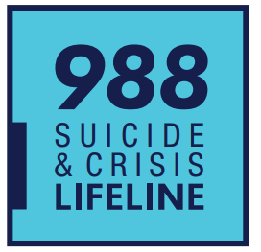

If you or someone you know needs support now,
call or text 988 or chat 988lifeline.org

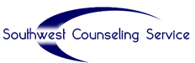
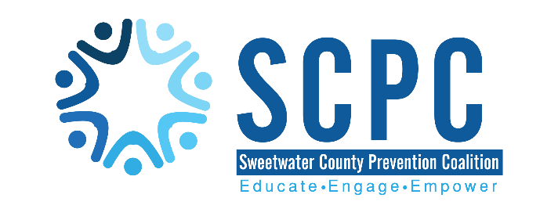
Our Mission: “Sweetwater County Prevention Coalition is committed to the enhancement of community safety and health with a primary focus on substance use and suicide prevention for Sweetwater County Residents.”
Our Vision: “Sweetwater County Prevention Coalition wants to educate and empower the community to make positive lifestyle choices.”

